**How to create web server on packet tracer**

When we search anything on Google, Bing, Mozila, safari or any web browser. Its result comes on web page that appears on screen.

So we are taking few PCs and one web server and one switch for connecting all devices. Make sure all devices should be connected by straight through cable because for connecting different devices, straight through cable is required. Assign IPs to each end device (server and PCs) of single network (192.168.1.0) with subnet mask 255.255.255.0 It can different as per your choice.

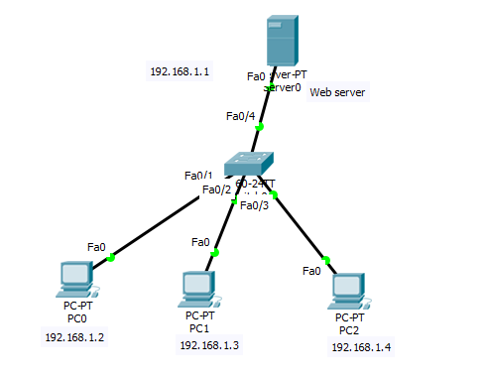

1. In next step we go on server >services>Http>select **both(HTTP & HTTPS)** **services** as **on** mode.

2. Now we can search webpage from **any connected PC**. This will so you only existing HTTP file when you put Server IP. Go to any **PC>Desktop>Web Browser>put server IP(192.168.1.1)>** click Enter. It will so you below result.

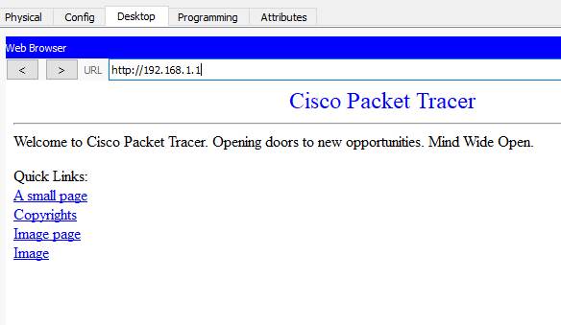

If you want to create your own webpage then it is very simple. Just follow path

Go to on server>services>HTTP>new file>just write you html code whatsoever you want.